**Assignment -2**

Python Programming

|  |  |
| --- | --- |
| Assignment Date | 27th September 2022 |
| Student Name | Jayasindhu.P |
| Student Roll Number | 2k19ece018 |
| Maximum Marks | 2 Marks |

**Question-1:**

Build a python code, assume u get temperature and humidity values (generated with random function to a variable) and write a condition to continuously detect alarm in case of high temperature.

**CODE :**

**import random**

**print ("welcome to me ")**

**temp=int(random.randint(0,100))**

**humid=int(random.randint(0,100))**

**if(temp>=1) and(temp<=20):**

**print (f"humidity level{humid}% cold breeze")**

**elif(temp>=21) and(temp<=29):**

**print (f"humidity level {humid}%, room temperature")**

**elif(temp>=30) and(temp<=54):**

**print (f"humidity level {humid}%, high temperature, switch on the AC ")**

**elif(temp>=-40) and(temp<=-1):**

**print (f"humidity level{humid}%, freezing")**

**else:**

**print ("humidity level 0%, house is burning")**

**CODE:**

|  |
| --- |
|  |
|  |
|  |
|  |
|  |
|  |
|  |
|  |  |

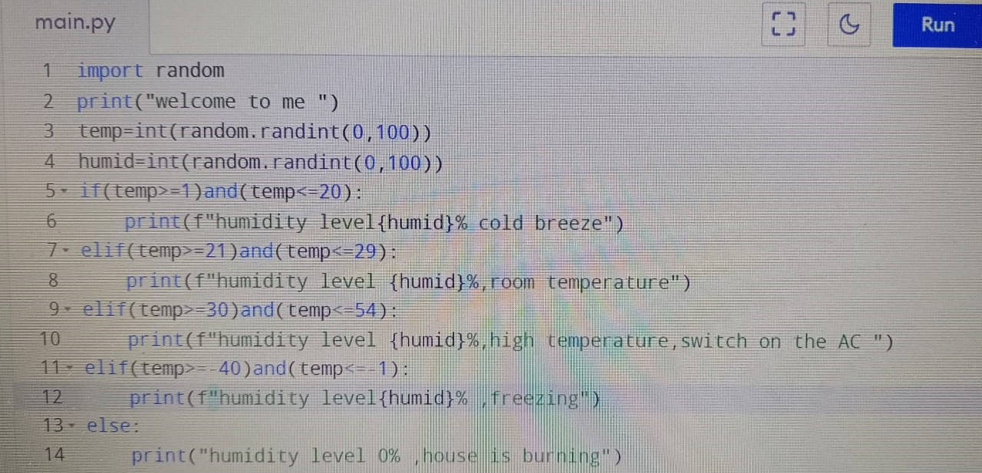

OUTPUT:

